Riga Technical University

FACULTY OF COMPUTER SCIENCE AND INFORMATION TECHNOLOGY

Fundamentals of Computer Graphics and Image Processing

Practical Work 3

TASK 3. BEZIER CURVE ALGORITHM

+ ADDITIONAL TASK

FCSIT
International Student
ZAID AHMAD SIDDIQUI
Stud. ID Nr.191ADB044

1.Task of Work
- During class you will be given the Bezier algorithm that can draw a Bezier curve with 3 control points. Change this program so that it would draw a Bezier curve with a different amount of control points, per your variant (see Table below).
- Upload the protocol of the task to Ortus (in *.pdf, *.doc or *.docx formats)
Variant  (the last digit of your student ID) | Amount of control points
0 | 6
1 | 7
2 | 8
3 | 9
4 | 6
5 | 7
6 | 8
7 | 9
8 | 8
9 | 7

Programming Code

public static int[] CPx = new int[12];
public static int[] CPy = new int[12];
public static double[] B = new double[12];
private void jButton1ActionPerformed(java.awt.event.ActionEvent evt) {

Random val = new Random(); //activate random value function
for(int i = 0; i<6 ; i++){
CPx[i] = val.nextInt(jPanel1.getWidth());
CPy[i] = val.nextInt(jPanel1.getHeight());
}
bezierCurve();
}

private void jPanel1MousePressed(java.awt.event.MouseEvent evt) {

int i = 0;
if(jRadioButton1.isSelected()) i = 0;
if(jRadioButton2.isSelected()) i = 1;
if(jRadioButton3.isSelected()) i = 2;
if(jRadioButton4.isSelected()) i = 3;
if(jRadioButton5.isSelected()) i = 4;
if(jRadioButton6.isSelected()) i = 5;

CPx[i] = evt.getX();
CPy[i] = evt.getY();
bezierCurve();
}
public void bezierCurve(){
Graphics g = jPanel1.getGraphics();
g.setColor(Color.WHITE);
g.fillRect(0, 0, jPanel1.getWidth(), jPanel1.getHeight());
g.setColor(Color.BLACK);
for(int i = 0; i<6 ; i++){
g.drawOval(CPx[i]-2 , CPy[i]-2 , 4 , 4);
g.drawString(String.valueOf(i+1), CPx[i]-3, CPy[i]-6);
}
g.setColor(Color.red);
double t = 0;
while (t<=1){
B[0] = Math.pow(1-t, 5);
B[1] = 5*t*(Math.pow(1-t, 4));
B[2] = 10*(Math.pow(t,2))*(Math.pow(1-t, 3));
B[3] = 10*(Math.pow(t,3))*(Math.pow(1-t, 2));
B[4] = 5*(Math.pow(t,4))*(1-t);
B[5] = Math.pow(t,5);

int xn = (int)Math.round(B[0]*CPx[0] + B[1]*CPx[1] + B[2]*CPx[2]+B[3]*CPx[3]+B[4]*CPx[4]+B[5]*CPx[5]);
int yn = (int)Math.round(B[0]*CPy[0] + B[1]*CPy[1] + B[2]*CPy[2]+ B[3]*CPy[3]+ B[4]*CPy[4]+ B[5]*CPy[5]);

g.drawRect(xn, yn, 1, 1);

t = t + 0.0001; //this is a 10000 pixels
}
}

Screen Shots
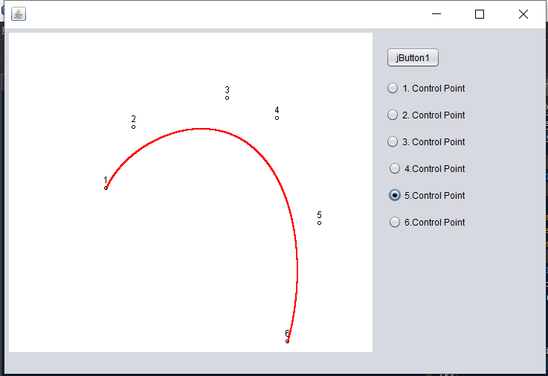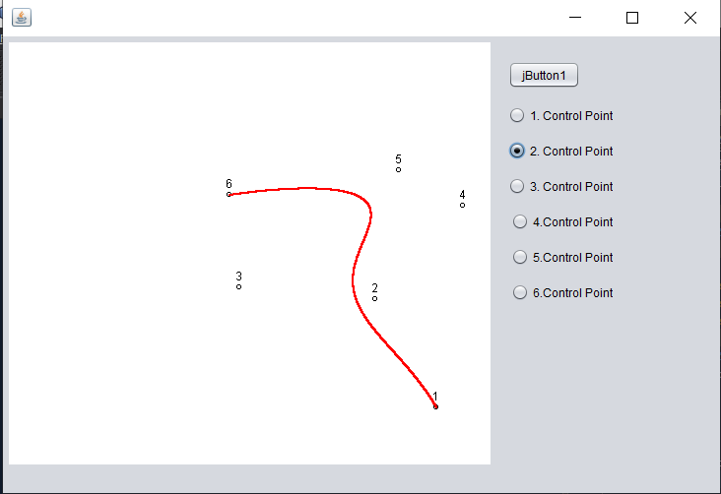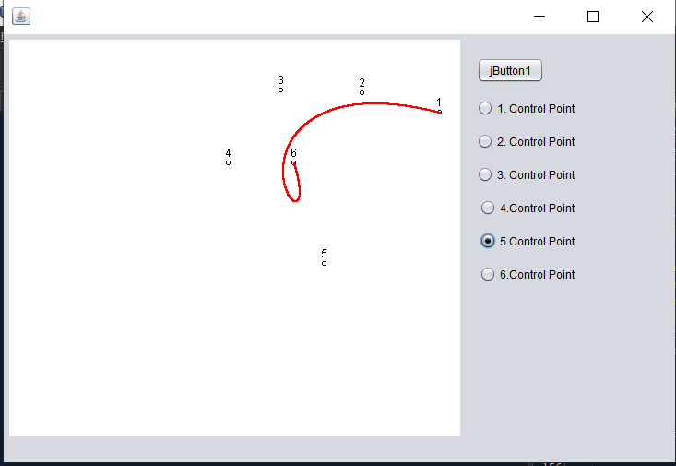

ADDITIONAL TASK

Task of Work
Make it possible to change the amount of control points (from 3 to 12), and draw the Bezier curve with these points.
Upload all program files to Ortus in an archive (in *.arj, *.zip or *.7z formats)
- Programming Code

public static int[] CPx = new int[12];
public static int[] CPy = new int[12];
public static double[] B = new double[12];
private void jButton1ActionPerformed(java.awt.event.ActionEvent evt) {
// TODO add your handling code here:
Random val = new Random(); //activate random value function
for(int i = 0; i<12 ; i++){
CPx[i] = val.nextInt(jPanel1.getWidth());
CPy[i] = val.nextInt(jPanel1.getHeight());
}
bezierCurve();
}

private void jRadioButton1ActionPerformed(java.awt.event.ActionEvent evt) {
// TODO add your handling code here:

}

private void jPanel1MousePressed(java.awt.event.MouseEvent evt) {

int i = 0;
if(jRadioButton1.isSelected()) i = 0;
if(jRadioButton2.isSelected()) i = 1;
if(jRadioButton3.isSelected()) i = 2;
if(jRadioButton7.isSelected()) i = 3;
if(jRadioButton8.isSelected()) i = 4;
if(jRadioButton9.isSelected()) i = 5;
if(jRadioButton4.isSelected()) i = 6;
if(jRadioButton5.isSelected()) i = 7;
if(jRadioButton6.isSelected()) i = 8;
if(jRadioButton10.isSelected()) i = 9;
if(jRadioButton11.isSelected()) i = 10;
if(jRadioButton12.isSelected()) i = 11;
CPx[i] = evt.getX();
CPy[i] = evt.getY();
bezierCurve();
// TODO add your handling code here:
}

/**
* @param args the command line arguments
*/

public void bezierCurve(){
Graphics g = jPanel1.getGraphics();
g.setColor(Color.WHITE);
g.fillRect(0, 0, jPanel1.getWidth(), jPanel1.getHeight());
g.setColor(Color.BLACK);
for(int i = 0; i<12 ; i++){
g.drawOval(CPx[i]-2 , CPy[i]-2 , 4 , 4);
g.drawString(String.valueOf(i+1), CPx[i]-3, CPy[i]-13);
}
g.setColor(Color.red);
double t = 0;

int n=Integer.parseInt(jTextField1.getText());
n = n-1;

while (t<=1){
for(int z=0;z<n+1;z++){
B[z]=(Fac(n)/(Fac(z)*Fac(n-z)))*(Math.pow(1-t, n-z))*(Math.pow(t, z));
}

double xn = 0;
double yn = 0;
for (int m = n; m>=0 ; m--){

xn = xn + (B[m]*CPx[m]);
yn = yn + (B[m]*CPy[m]);
}
g.drawRect((int)Math.round(xn), (int)Math.round(yn), 1, 1); // because drawrect only can int values.

t = t + 0.0001;

}

}

public int Fac(int n){
if(n==0){
return 1;

} else{
for (int x = n-1; x > 0; x--){
n*=x;
}
return n;
}
}

Screen Shots
